BtS Unaltered Gameplay

Version 2.11

BUG comprises a vast array of new items. The main feature and over-riding approach that every element added had to provide no additional information that is not available in the unmodified BtS game. That is, there is no alteration to the basic game play. All BUG features are optional, that is, the modifications that BUG brings to the game can be turned off.
The BtS Unaltered Gameplay files would be stored in the ‘C:\Documents and Settings\user\My Documents\My Games\Beyond the Sword\’.

General
This section will provide details about the General features build into the BUG mod. Here is a screenshot of the options screen:
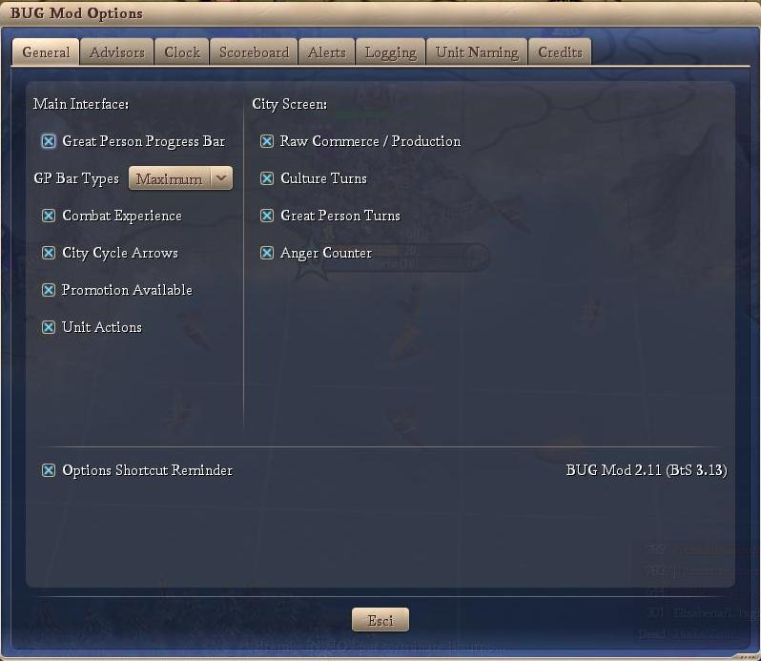
The individual General features are discussed below.
- Main Interface
  - Great Person Progress Bar
If checked, the Great Person Progress Bar is displayed. If the user clicks on the tab, the highlighted city screen is opened. There are three display options as illustrated below.
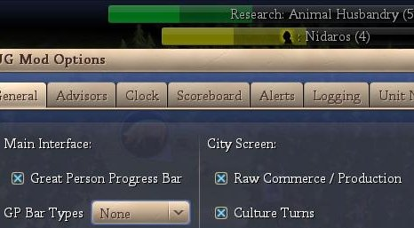
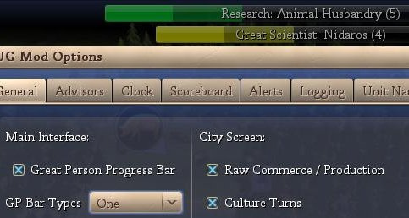
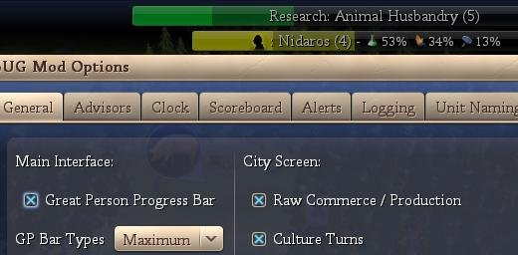
  - City Cycle Arrows
If checked, the City Cycle Arrows are displayed (see below). By clicking on the right / left arrows, the user is taken to the next city in the cycle while in the main interface screen.
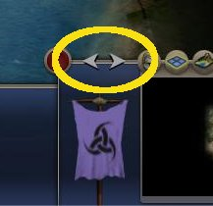
  - Combat Experience
If checked, the Combat Experience counter from the F5 screen is displayed (see below: the strong arm with the 0/30).
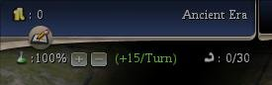
  - Promotion Available
If checked, a unit with a promotion available has a light blue highlight around its plot icon (see below: the blue highlight around the warrior)
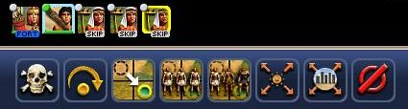
  - Unit Actions
If checked, a unit that has a pre-defined action (heal, goto, automated, fortified, etc) has text describing the action added to the bottom of its plot icon (see below: the ‘FORT’ on the archer signifying fortified and the ‘SKIP’ on the workers signifying that those units have been skipped).
- City Screen
  - Raw Commerce / Production
If checked, the City Screen shows the city’s raw production or commerce (see below: city production (left) and city commerce (right)). A button is available so the user can cycle between production or commerce. The source of the production or commerce is also shown.
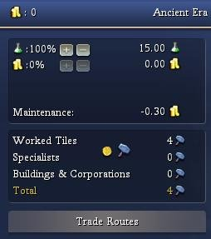 | 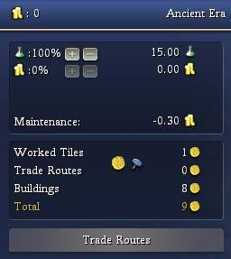
  - Culture Turns
If checked, the number of turns to the next cultural level is displayed (see below). No turns are displayed if the city is already Legendary or the city is not producing any culture.
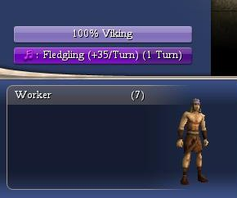
  - Great Person Turns
If checked, the number of turns to the next Great Person is displayed (see below). No turns are displayed if the city or the city is not producing any Great Person points.
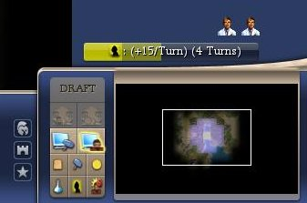
- Options Shortcut Reminder
If checked, the BUG options screen short cut is displayed (see below).
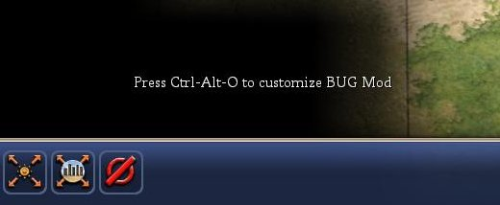

Advisors
This section will provide details about the Advisor features build into the BUG mod. Here is a screenshot of the options screen:
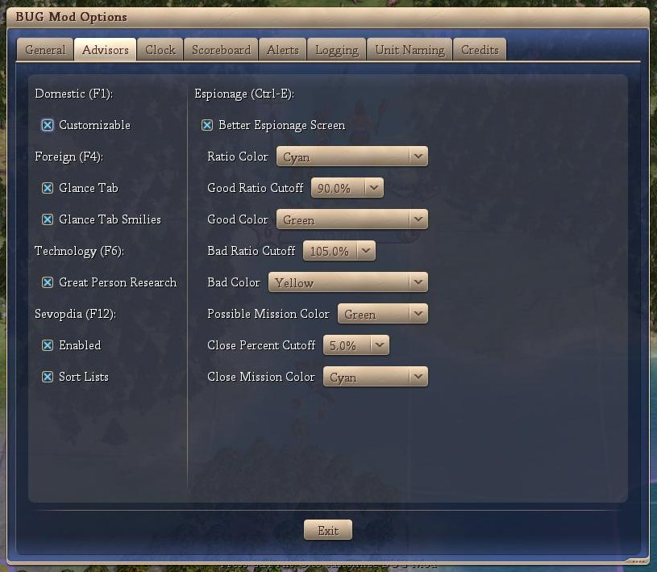
The individual Advisor features are discussed below.
- Domestic
If checked, then the built in Domestic Advisor is replaced with the Customizable Domestic.
The Customizable Domestic Advisor (CDA) has a default view that the user can modify. The default CDA contains approximately 5 pages. There is also an optimized version of the CDA configure file that contains 19 pages. There are more than 450 columns that the user can add to the advisor, and they can be organized inside an unlimited number of pages.
The customization of CDA can be done from within the CDA customize interface, that can be accessed from CDA clicking on the parchment button near the name of the current page. Here you can see a picture of the buttons of the CDA customize interface and a quick description of them.
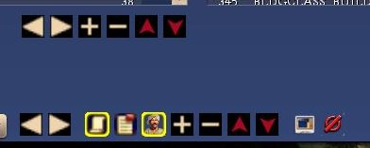
Columns buttons: (upper row)
white left arrow: decrease the size of the selected column (in the left panel)
white right arrow: increase the size of the selected column (in the left panel)
white +: add the selected column (the selected column in the right pane is added to the left one)
white -: remove the selected column (the selected column in the left pane is removed from it)
red up arrow: move the selected column up (so it will be displayed before in the CDA page)
red down arrow: move the column down (so it will be displayed after in the CDA page)

Pages buttons: (lower row)
list: shows the current page and allow you to go to another one
white left arrow: go to the previous page
white right arrow: go to the next page
parchment: toggle normal interface and customization interface
pinned paper: rename selected page
head: add/remove to/from the page the bottom bar with specialists, culture list and GP list
white +: add a new page
white -: remove the selected page
red up arrow: move the selected page up in the list
red down arrow: move the selected page down in the list
monitor: save the last customizations
ban sign: delete last customizations

- Foreign
  - Glance Tab
If checked, the Glance tab is included
  - Glance Tab Smilies
If checked, the Glance tab includes Smilies similar to the scoreboard smilies
- Technology
  - Great Person Research
If checked, a row of great people followed by two techs are shown. The first of these two techs indicate the tech the great person would lightbulb. The second of these two techs indicates the tech the great person would lightbulb if the currently selected tech was known. The picture below shows that a Great Scientist will lightbult roads and if you research Mining, he will lightbulb roads. If, however (insert), you research Animal Husbandry, the Great Scientist will lightbulb writing.
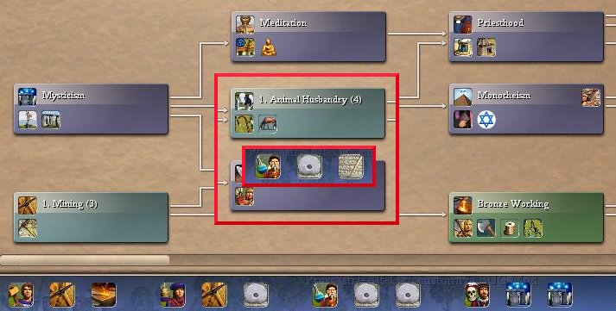
- Sevopedia
  - Enabled
If checked, the in-game Civilopedia is replaced with the Sevopedia.
  - Sort List
If checked, the lists are sorted.
The purpose of Sevopedia is to reorganize the content of the Civilopedia (and thus it would appear that it will not provide any spoilerish information). Below you can see some example screen of Sevopedia (for Buildings, Techs and Leaders).
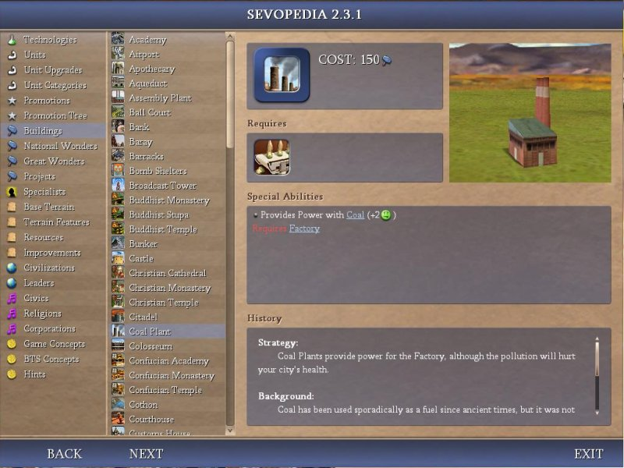
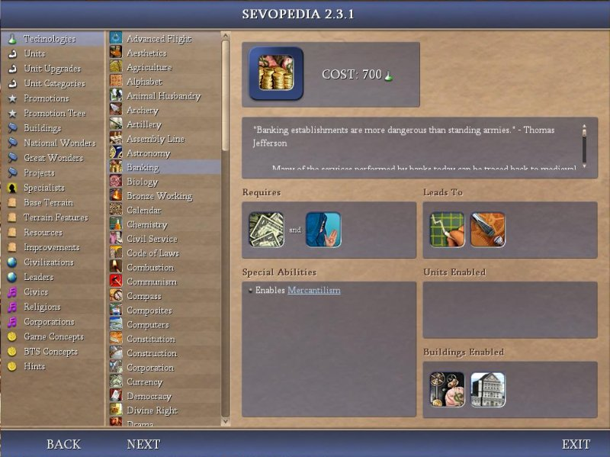
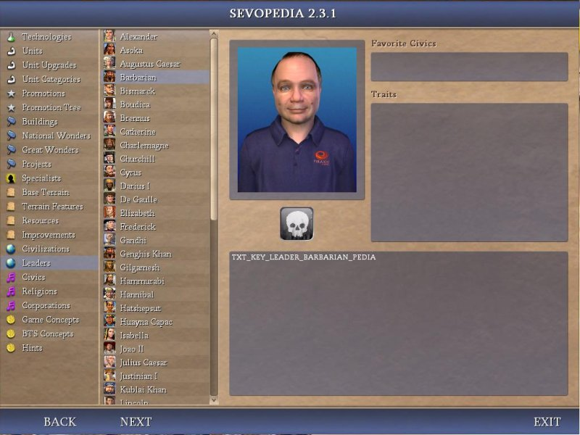
- Espionage
If checked, then the in-game Espionage Advisor is replaced.
The BUG version of the Espionage Advisor is similar to the standard BtS version except it adds color coding and rearranged some fields on the left of the screen. The mission costs (close to being able to perform missing and can perform mission) are color coded as well as the relative cost of the missions.
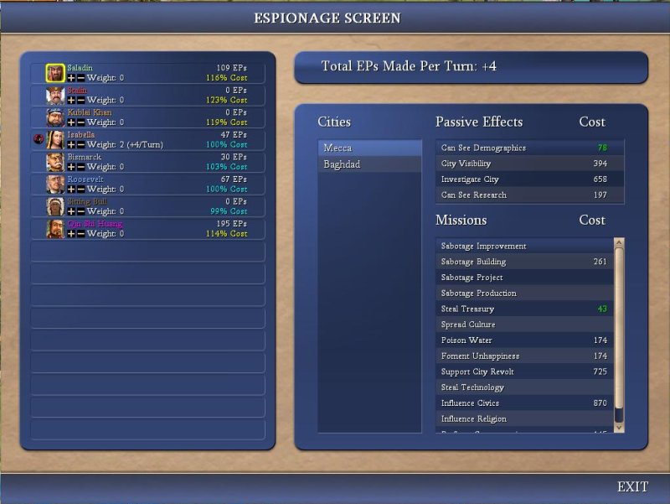

Clock
This section will provide details about the Clock features build into the BUG mod. Here is a screenshot of the options screen:
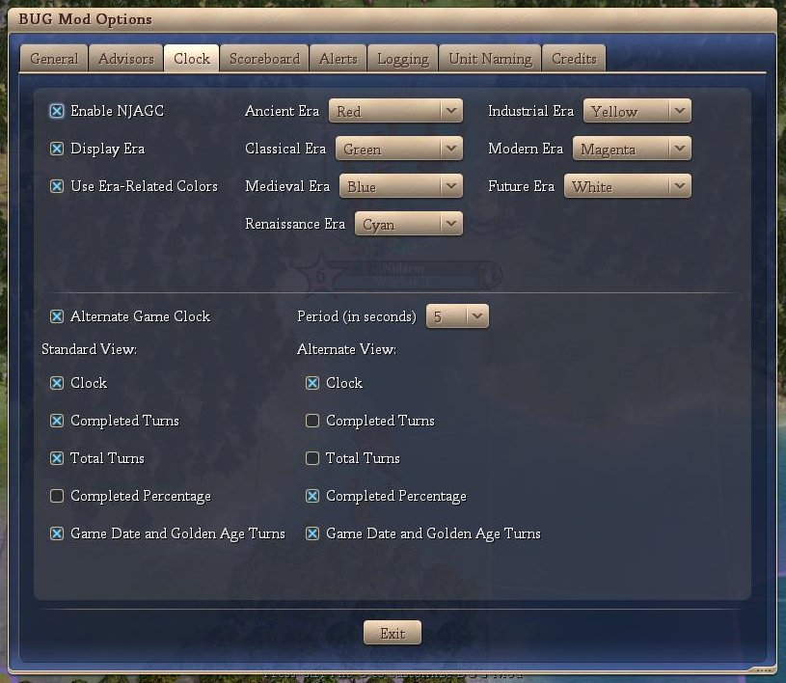
The individual Clock features are discussed below.
- Enable NJAGC (Not Just Another Game Clock)
If this option is checked then the Clock portion of BUG is enabled.
- Display Era
If checked, then the current era (according to the player) is displayed.
- Use Era-Related Colors
If checked, then the current era (according to the player) is displayed in the color that the user can specify (drop downs to the right).
- Alternate Game Clock
If checked, then the clock alternates between ‘Standard View’ and ‘Alternate View’. The user can specify the alternating time period in seconds. If not checked, only the ‘Standard View’ is displayed.
- Standard / Alternate View(s)
  - Clock
If checked, the time is displayed
  - Completed Turns
If checked, the time is displayed
  - Total Turns
If checked, the total turns for this game are displayed only if ‘time victory’ is enabled.
  - Completed Percentage
If checked, the percent complete (as measured by turns) is displayed only if ‘time victory’ is enabled.
  - Game Date and Golden Age Turns
If checked, the game date and Golden Age turns are displayed.
The following is a sample screenshot showing the Standard View (upper left and upper right):

The following is a sample screen shot showing the Alternate View.
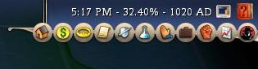

Scoreboard
This section will provide details from the scoreboard tweaks enabled by BUG. Here is a screenshot of the options screen:
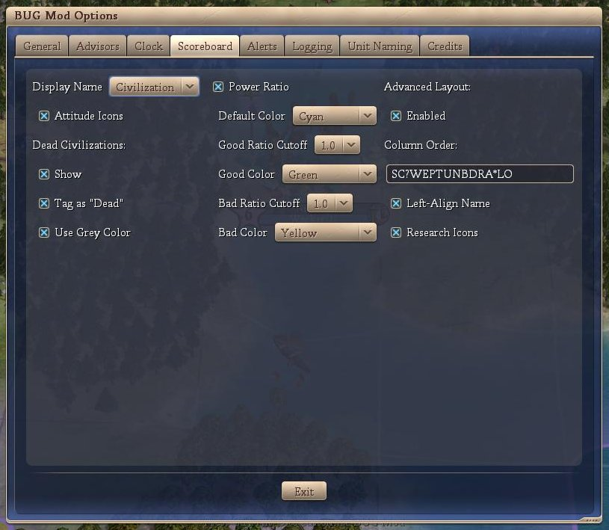
The balance of this section will detail each feature independently.
- Display Name
There are 3 options in this drop down:
  - Name: displays the leader name on the scoreboard (this is the default behavior of Civ4-BtS);
  - Civ: displays the civilization name on the scoreboard;
  - Both: displays leader name / civilization name on the scoreboard.
- Attitude Icons
This option displays an icon next to the “display name” showing the civilization attitude towards the player. It’s the same as opening the Foreign Advisor screen or even hovering the mouse over the civilization name. The icons stand for:
  - Red Frowning Face: Furious
  - Cyan Frowning Face: Annoyed
  - Grey Straight Month Face: Cautious
  - Green Smiling Face: Pleased
  - Yellow Grinning Face: Friendly
- Dead Civilizations
This group of options shows how dead civilizations are displayed on the scoreboard. The options are:
  - Show
This is the default behavior of Vanilla and Warlords versions. BtS’ default is to hide the dead civilization.
  - Tag as “Dead”
This option replaces the zero score with the text “Dead”.
  - Use Grey Color
This option greys out the dead civilization.
- Power Ratio
This option displays the power ratio between your civilization and the indicated civilization, expressed to 1 decimal place only. It is a ratio of your power to their power. Numbers greater than 1 indicate that you are stronger than them. This information is only displayed if you have enough espionage points to gather the required information. There are options to use colors as a visual aid.
The color options are:
  - Default color: default display;
  - Good Ratio Cutoff: values greater than this number will be considered good;
  - Good Color: display color for power ratios higher than the ‘good ratio cutoff’;
  - Bad Ratio Cutoff: values shorter than this number will be considered bad
  - Bad Color: display color for power ratios lower than the ‘bad ratio cutoff’.
- Advanced layout
The Advanced Layout option is enabled if the user selects the ‘Enabled’.
The ‘Column Order’ key enables the user to modify the display order of items in the scoreboard and it also enables the user to remove items from the scoreboard. The following table shows the keys available, some restrictions on their display as well as differences between the BUG mod’s display and raw BtS; it also includes comments on the ‘Left-Align Name’ and ‘Tech Icons’ check boxes.
Code | Description | Restrictions | Differences to raw BtS
S | The civ's score | - | -
C | The civ's/leader's name | - | Column same width for all leaders.  Left aligned if the ‘Left-Align Name’ option is checked
? | Shows a ‘?’ if you haven't met the civ of a human player yet | Multi-player Only | -
W | Current WAR status | Rivals Only | Fist displayed instead of ‘WAR’
E | Shows a spy icon if you have a positive espionage point ratio against the civ | Rivals Only | -
P | The civ's power ratio | Rivals Only | See text above
T | The tech the civ is researching (vassals, teammates and espionage) | Rivals Only | Nil unless ‘Research Icons’ option is checked in which case the tech icon is shown
U | The number of research turns left (see T above) | Rivals Only | -
N | Shows the three-arrow icon when you are connected to the civ's trade network | Rivals Only | -
B | Shows a scroll icon when you have signed an open borders agreement with the civ | Rivals Only | -
D | Shows a similar scroll icon when you have signed a defensive pact with the civ | Rivals Only | -
R | The civ's state religion |  | -
A | The civ's attitude toward you | Rivals Only | See text above
* | You are waiting for this civ to finish its turn | Online multi-player only | -
L | The civ's network stats (ping) | Online multi-player only | -
O | The network player is out-of-sync | Online multi-player only | -

Alerts
This section will provide details about the Alert features build into the BUG mod. Here is a screenshot of the options screen:
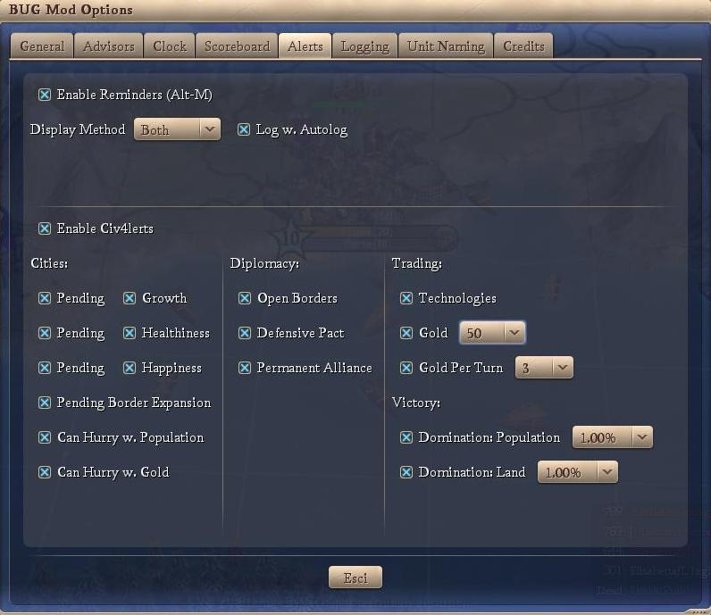

Reminders
The individual Reminder features are discussed below:
- Enable Reminders (Alt-M)
If this options is checked, then the Reminder portion of BUG is enabled. You can store a reminder via Alt-M on the keyboard. This will bring up a dialog box (see below) and you can set a reminder text as well as a reminder turn.
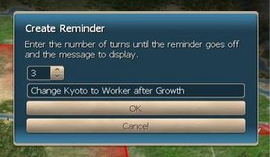
Then after the number of turns you specify, another dialog box pups up (see below – this is not the show associated with the above dialog box) with your reminder. Reminders are stored across saves.
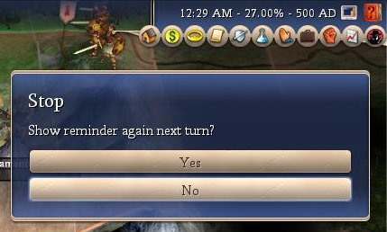
You can set the same reminder to appear next turn if you so desire.
- Display Method
This is the display method for the reminder. The options are:
  - dialog box (as above)
  - message on screen with other Civ4 messages
  - both
- Log w. Autolog
When checked, this logs the setting and firing of reminders in the autolog / logger (the logger must also be enabled).

Alerts
The individual Alert features are discussed below:
- Enable Civ4lerts
If this options is checked, then the Civ4lerts portion of BUG is enabled.
- Cities
  - Growth
If checked, an alert that a city has grown (or shrunk) this turn is displayed.
  - Pending (Growth)
If checked, an alert that a city will grow (or shrink) next turn is displayed.
  - Healthiness
If checked, an alert that a city has increased its Healthiness (or Unhealthiness) is displayed.
  - Pending (Healthiness)
If checked, an alert that a city will increase its Healthiness (or Unhealthiness) is displayed.
  - Happiness
If checked, an alert that a city has increased its Happiness (or Anger) is displayed.
  - Pending (Happiness)
If checked, an alert that a city will increase its Happiness (or Anger) is displayed.
  - Pending Border Expansion
If checked, an alert that a city border expansion will occur next turn is displayed.
  - Can Hurry w. Population
If checked, an alert that a city can hurry its production sacrificing some citizens is displayed.
  - Can Hurry w. Gold
If checked, an alert that a city can hurry its production paying some gold is displayed.
- Diplomacy
  - Open Borders
If checked, an alert that a civilization will sign open borders is displayed (first turn that option is available only).
  - Defensive Pact
If checked, an alert that a civilization will sign a defensive pact is displayed (first turn that option is available only).
  - Permanent Alliances
If checked, an alert that a civilization will sign a permanent alliance is displayed (first turn that option is available only).
- Trading
  - Technologies
If checked, an alert that a technologies to trade is displayed (first turn that tech is available only).
  - Gold
If checked, an alert that a civilization has gold to trade is displayed (each turn); the user can set the limit of the alert.
  - Gold per Turn
If checked, an alert that a civilization has gold per turn to trade is displayed (each turn); the user can set the limit of the alert.
- Victory
  - Domination: Population
If checked, an alert that you are approaching or exceeded the population domination limit; the user can set the amount below the population domination limit that activates the alert.
  - Domination: Land
If checked, an alert that you are approaching or exceeded the land domination limit; the user can set the amount below the land domination limit that activates the alert.

Logging
The BUG mod includes a logging portion that logs the general events that occur in the game to a text file. This is mainly included for succession game (SG) players as a way of recording the mundane events that occur. Typically, SG players / events have house rules concerning the use (or otherwise) of loggers.
The options shown on the BUG mod’s logging option screen are shown below.
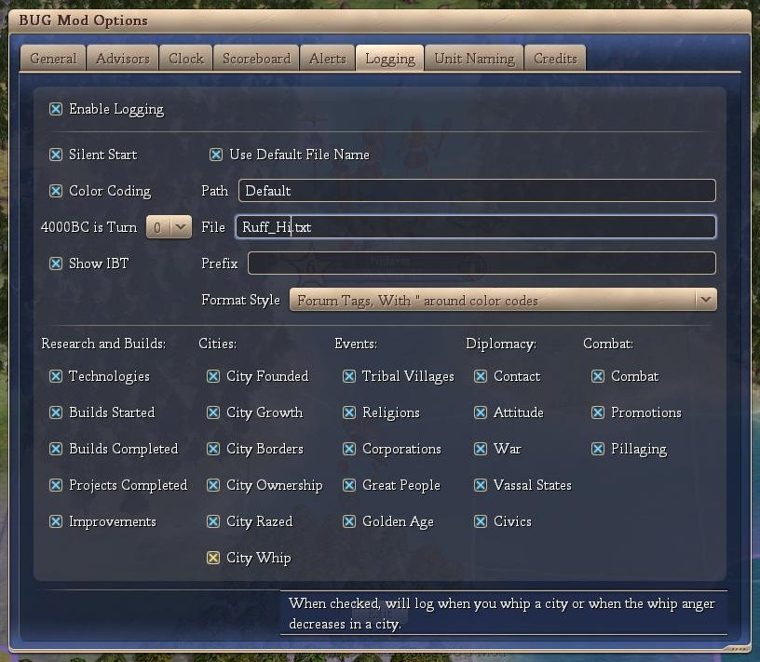
These features are discussed below.
- Enable Logging
If this options is checked, then the logging portion of BUG is enabled and logging will occur.
- Silent Start
This option means that logging of the game will automatically start and the file name will be set to the name of the player. In the above graphic, the game was started by the player ‘Ruff_Hi’ and the logging will be written to a file ‘Ruff_Hi.txt’ that is in the default file path (my docs\BtS\autolog).
- Color Coding
If color coding is checked, then the log will include various color characteristics that group the events being logged by color. The user cannot adjust the colors.
- 4000BC is turn ?
The logger includes code to count 4000BC as Turn 0 or Turn 1. The user can specify which counter they wish to use.
- Show IBT
If this option is checked, then the logger will include a line that contains “IBT:” (IBT stands for “In between Turns”) at the conclusion of the players turn and prior to the AIs turns.
- Use Default File Name
If ‘Silent Start’ is not checked, then the player must start the logger manually. The key to start the logger is Alt-L. If the ‘Use Default File Name’ option is checked, then the default name (Player’s Name) is used for the text file. If the ‘Use Default File Name’ option is not checked, then the player must supply a file name via an input box.
- Path
The player can override the default path for the location of the logging file.
- File
The player can override the default file name.
- Prefix
The player can manually add a comment to the log file (Alt-E). The logger records this manual entry with the addition of the ‘Prefix’.
- Format Style
There are 4 format styles available for the log file.
  - None: no formatting;
  - HTML: html tags are included;
  - Forum with ‘“’: Forum tags with ‘“’s around the color text (if any) are included;
  - Forum without ‘“’: Forum tags without ‘“’s around the color text (if any) are included.

- Research and Builds
  - Technologies
If checked, technologies gained through research or trade are logged, Technologies started are logged together with the game’s estimate of the number of turns to complete.
  - Builds Started
If checked, city builds (either buildings, wonders or units) started are logged together with the game’s estimate of the number of turns to complete
  - Builds Completed
If checked, city builds (either buildings, wonders or units) completed are logged.
  - Projects Completed
If checked, city projects completed are logged.
  - Improvements
If checked, city improvements (cottages, farms, mines, etc) are logged.
- Cities
  - City Founded
If checked, cities founded are logged.
  - City Growth
If checked, city growth is logged.
  - City Borders
If checked, city border expansions are logged.
  - City Ownership
If checked, city ownership, or change in ownership, is logged.
  - City Razed
If checked, city destruction is logged.
  - City Whipped
If checked, rushing the build queue via whipping is logged as well as when the city whip anger decreases.
- Events
  - Tribal Villages
If checked, the result from tribal villages is logged.
  - Religions
If checked, the founding or spread of religions is logged.
  - Corporations
If checked, the founding or spread of corporations is logged.
  - Great People
If checked, the birth of Great People is logged.
  - Golden Age
If checked, the start and end of Golden Ages are logged.
- Diplomacy
  - Contact
If checked, initial contact between the player and other civilizations is logged.
  - Attitude
If checked, attitude changes between known civilizations is logged (both civilizations must be known to the player).
  - War
If checked, the war status between known civilizations is logged.
  - Vessel States
If checked, the vessel state status between known civilizations is logged.
  - Civics
If checked, civic changes of known civilizations are logged.
- Combat
  - Combat
If checked, combat between the player’s units and units from another civilization is logged. Also logged are the results, general location, victory probability and remaining health of the unit.
  - Promotions
If checked, promotions granted to the player’s units are logged.
  - Pillaging
If checked, pillaging performed by the player’s units regardless of location or pillaging by the AI units on the player’s tiles, is logged.
The following is a sample of a typical log file.
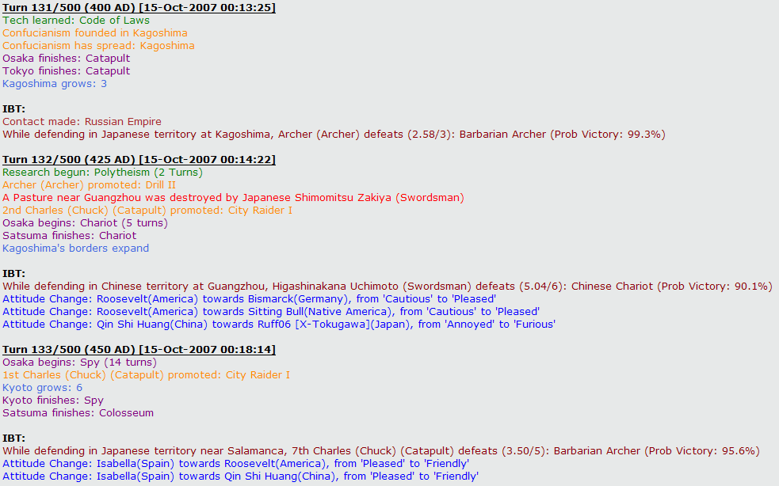

Unit Naming
The BUG mod includes the Generic Unit Naming (GUN) mod. This mod is designed to give the player an extremely flexible method of naming his units. The basic approach is that the player constructs a naming convention that he want to use (see later) and then assigns that naming convention to all units, all units of the same combat type or all units of the same unit type in the same era.
The options shown on the BUG mod’s Unit Naming option screen are shown below.
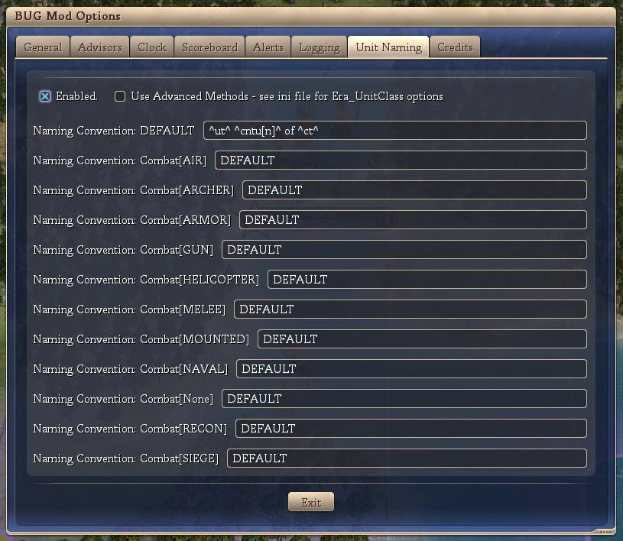
These features are discussed below:
- Enabled
If this option is checked, then the unit naming portion of BUG is enabled and units produced will be given a name depending on the player defined naming convention. If this option is not checked, then the unit naming portion of BUG is not enabled and default Civ4 unit naming will occur.
- Use Advanced
If checked, than the unit naming code will extract the naming convention from the BUG Mod.ini using the unit type and the current player era. If this naming convention is “DEFAULT”, then the naming convention associated with the unit’s combat type will be used. If this naming convention is “DEFAULT”, then the ‘default’ naming convention will be used.
For example: An axe constructed in the ancient era will use the naming convention stored with the ini key “AXE_ANCIENT”. If this naming convention is “DEFAULT”, then the naming convention stored with the ini key “Melee” will be used. If this naming convention is “DEFAULT”, then the naming convention stored with the ini key “DEFAULT” will be used.
If this option is not checked, then the naming convention associated with the unit’s combat type will be used. If this naming convention is “DEFAULT”, then the ‘default’ naming convention will be used.
The screen also shows the various naming conventions used for the 10 combat types in the game. An 11th quasi-combat type (None) has been added for settlers, workers, missionaries, etc.
The following is the code that controls the name that your unit will have.
  - ^civ4^ no naming convention, uses standard civ4
  - ^rd^ random name
  - ^rc^ random civ related name
  - ^ct^ city
  - ^cv^ civilization
  - ^ut^ unit
  - ^cb^ combat type
  - ^dm^ domain
  - ^ld^ leader
  - ^cnt[f]^ count across all units
  - ^cntu[f]^ count across same unit
  - ^cntct[f]^ count across same city
  - ^cntuct[f]^ count across same unit/city
  - ^cntc[f]^ count across same combat type
  - ^cntd[f]^ count across same domain
  - ^tt1[f][x:y]^ total where the total is a random number between x and y
  - ^tt2[f][x]^ total count (starts at x, incremented by 1 each time ^tt1 is reset to 1)
There are a lot of number formats; [f] can be:
  - 's' for silent (not shown)
  - 'A' for upper case alpha (A, B, C, D, ...)
  - 'a' for lower case alpha (a, b, c, d, ...)
  - 'p' for phonetic (alpha, bravo, charlie, delta, ...)
  - 'g' for greek (alpha, beta, gamma, delta, ...)
  - 'n' for number (1, 2, 3, 4, ...)
  - 'o' for ordinal (1st, 2nd, 3rd, 4th, ...)
  - 'r' for roman (I, II, III, IV, ...)
Some number formats have a built in max (i.e. alpha); in these situations, the numbering loops back to the start. For example, if you pass the number ‘30’ and ask for the number to be formatted with an ‘A’ (upper case alpha) then it will return ‘D’.

Credits
This section will provide a screen shot(s) of the Credit tab from the ‘BUG Mod Options’ screen (below).
No configuration is possible in this tab, it is a read-only screen.
